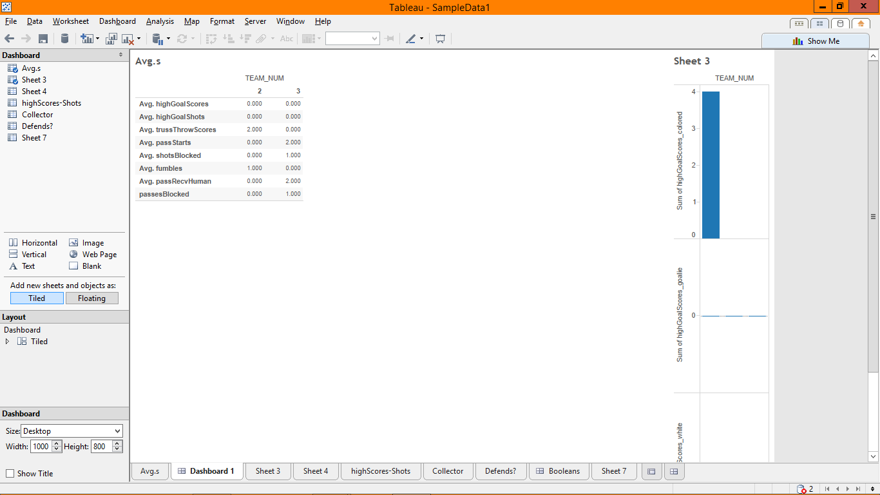

Avgs on the left, high shots by position on the right

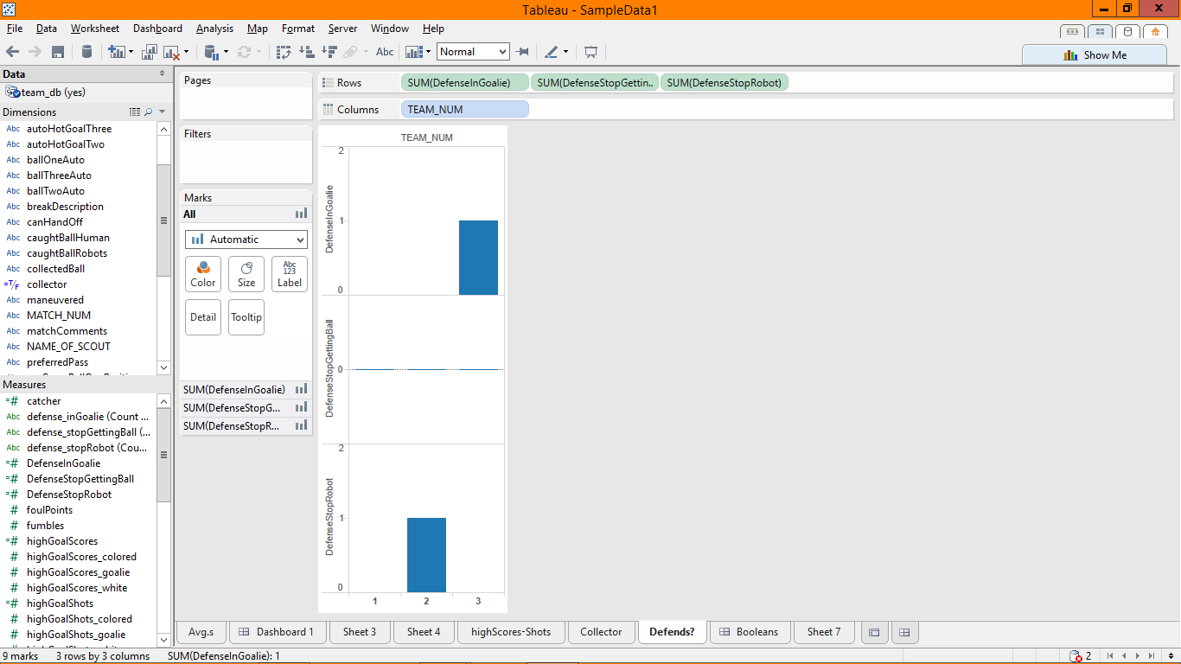

Defense played (I can do the same for roles)

Number of matches is number of records